UNBELIEVABLE HERO MOM
During an early morning response to a house fire in Santa Rose de Temuco, Chile , fire-fighters witnessed the unbelievable. A mother dog risked her life to save her puppies from the fire surrounding the burning house, which started because of a car bomb..
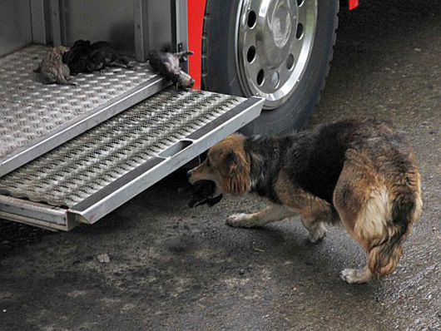
The mother dog, Amanda, raced back and forth between the house, putting her 10 day old puppies in the safest place she could find - a firetruck!
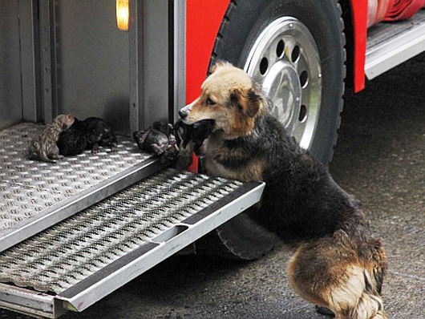
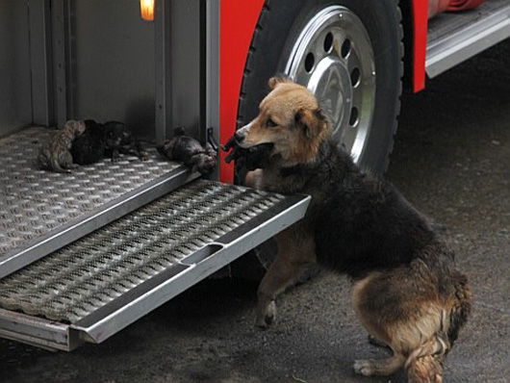
She didn't stop racing back into the fire until all of her puppies were safely away from the fire. The firemen on scene could not believe their eyes. Most people have never seen a dog this smart or this brave!
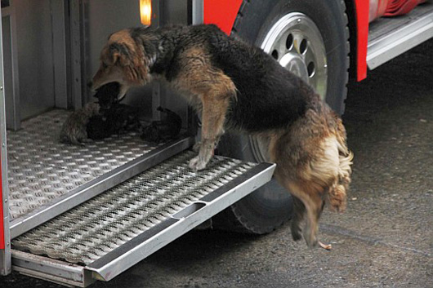
After rescuing all of her pups from the blaze, Amanda sat down next to them, protecting them with her body. Onlookers called an emergency veterinary service and she and her pups were rushed to the hospital. Aside from one puppy being treated for serious us burns, the entire family are alive and well - thanks to the bravery of Amanda! What a heroic mother! :)
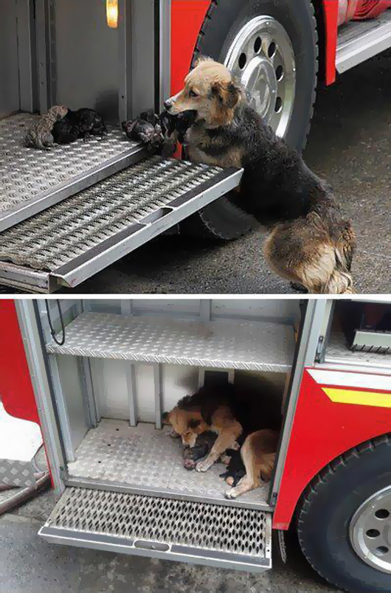
HOW AMAZING IS THAT STORY? AND PEOPLE CALL THEM DUMB!!!

